1. **Install the Fortigate VPN client software**
   1. 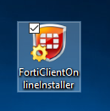Download the Forticlient software   
      <http://www.forticlient.com/downloads>
   2. Run the ForticlientOnlineInstaller.exe
   3. Skip the Virus cleaner scan by clicking Close
   4. Finish the installation using selecting all the default settings when prompted.
2. **Configure the FortiClient software**
   1. Run FortiClient
   2. 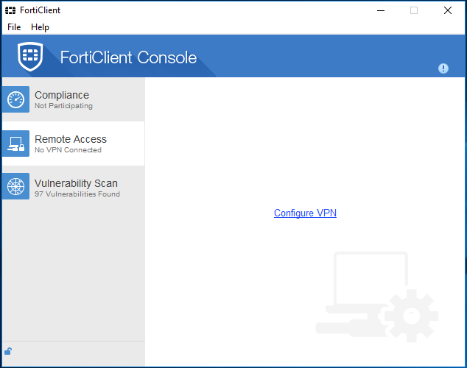Click the "Remote Access" tab and click "Configure VPN".
   3. 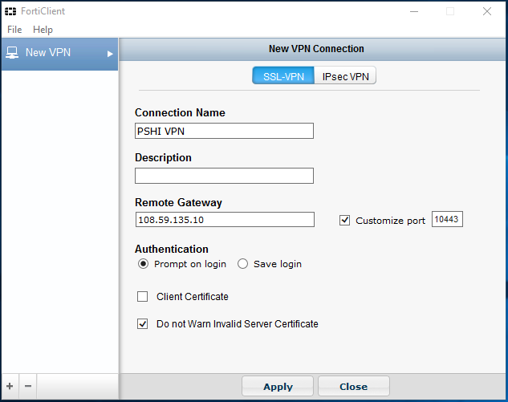Enter the following connection info:
      1. Connection Name: PSHI VPN
      2. Remote Gateway: 108.59.135.10
      3. Check "Customize port"
      4. Customize port: 10443
      5. Authentication: Prompt on logon
      6. Check "Do not Warn Invalid Server Certificate"
      7. Click Apply
3. 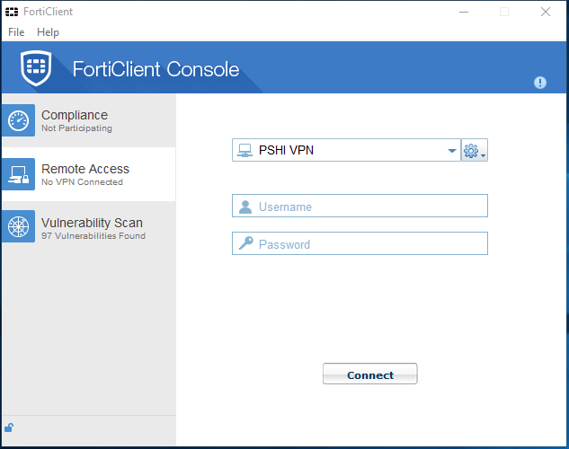**Connect to the PSHI VPN**
   1. Open the Forticlient Console
   2. Choose “PSHI VPN”
   3. Enter your username and password.
   4. Click “Connect”  
        
      *If you don’t have your username and password, please contact Jon:*

[*jon@limpacific.com*](mailto:jon@limpacific.com) *808-225-7618*

1. 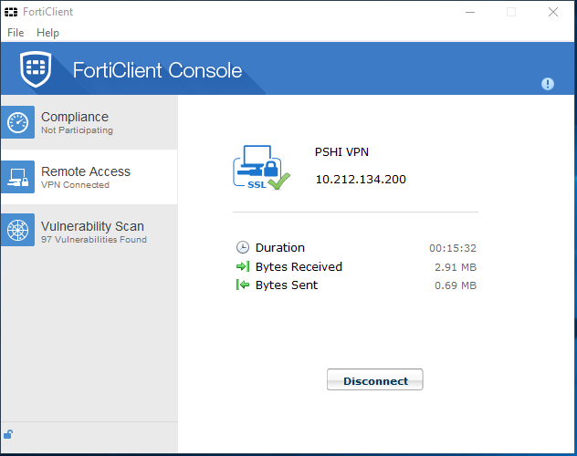**If you don’t receive an error, you are connected to the PSHI Office Network.**